

Trustee appointment

Appointment of a qualified accountant to the Board and to the Finance, Audit and Risk Committee

Information Pack

March – May 2024



## Contents

**Welcome from the Chair of the People and Nominations Committee** 2

**Who we are**  3

**Our history** 3

**Our vision, mission and values**                                        4

**Inclusion at Family Fund** 5

**Joining us as a trustee** 6

**Meet the Chair of FARC**  7

**Meet some of our trustees** 8

**Trustee role and responsibilities** 10

**The liabilities of trusteeship** 12

**Trustees’ standards**  13

**Trustee role description** 15

**Support in the role** 17

**Application process**  17



## Welcome from Jonathan Evans, Chair of People and Nominations Committee

Thank you for your interest in the role of Trustee at Family Fund, a charity that has provided essential grant support and information services to families on low incomes raising disabled or seriously ill children and young people across the UK for 50 years.

The impact of the COVID pandemic resulted in a dramatic increase in the number of families turning to Family Fund for support. This was a challenge that Family Fund rose to meet, with the support of those who provided funding, and our staff who worked tirelessly throughout.

Life has not returned to normal for the families that we support, and the level of need continues to grow. As a result, Family Fund continues to receive significant numbers of applications from families across all parts of the UK.

Our new five-year strategy, ‘Being there for Families 2023 – 2028’ was launched last year, the year in which we celebrated our 50th anniversary. It is ambitious and innovative but also retains the focus on practical financial support that families continue to need and expect from us – support that in times of need can often be a lifeline.

The need for our support continues to grow and maintaining it is an ongoing challenge that requires us to find ever-more creative and innovative ways of growing our funding to support those that need us. We must make every £1 that we receive go further, communicate our work and build our brand profile for the benefit of those that we support.

Trustees at Family Fund play an active role in governing the charity and its trading subsidiary and are responsible for setting vision and strategic priorities, and for ensuring that the charity complies with legal, charitable and financial requirements.

We are seeking a qualified accountant to join our Board of Trustees. All our Trustees are also members of at least one Committee, and you will join our Finance, Audit and Risk Committee. Details of the skills and experience we are seeking are set out later in this pack along with some insight from Gareth Lambert, Chair of the Finance, Audit and Risk Committee on what he is hoping our new Trustee will bring to the Committee.

This pack also includes information about the organisation, the role of trustees and the appointment process.

I hope you will be attracted to this exciting challenge  
and the opportunity to join our team to make a

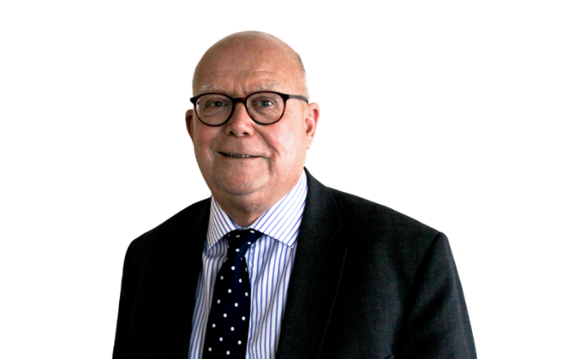difference to the lives of tens of thousands of disabled

and seriously ill children and young people each year.

Regards,

Jonathan Evans

## Who We Are

Family Fund is the UK’s largest charity providing essential grant support to families raising disabled or seriously ill children and young people. We believe that all families raising disabled or seriously ill children and young people should have the same opportunities as others. Beginning with the most vulnerable, those on low incomes, we aim to make a difference to the lives of children, young people and their families across the UK.

We provide grants for a wide range of items, such as washing machines, sensory toys, family breaks, bedding, tablets, furniture, outdoor play equipment, clothing and computers. Our information and support service complements our grants and aims to improve the wellbeing of disabled children and their families.

It can be a struggle financially, emotionally and physically for many families raising a disabled or seriously ill child, and our grants and services help break down many of the barriers families face, improving their quality of life and easing the additional daily pressures. For more information on our impact, and to read our annual report go to our website [www.familyfund.org.uk](http://www.familyfund.org.uk/)

## Our history

Family Fund was established in 1973 following a public campaign on behalf of children affected by Thalidomide.

It was initially established as part of the Joseph Rowntree Foundation to support the UK government in providing financial help to those who needed it. We became an independent charity in 1996.

Our very first grant was to support a family with the cost of visiting their child in hospital and was £26. Years later we are still providing practical support to tens of thousands of families every year.

Today, based mainly in York, Family Fund is one of the largest charities in the UK. We receive funding from the four UK governments, Trusts and foundations, donations and income we generate through the work of our trading arm, Family Fund Business Services (FFBS), which was set up in 2013 to help support our sustainability and provide unrestricted income to the charity.

Over the last 50 years, we have grown in size and profile, and we are providing more grants and services than ever before. But there is still more to be done. It’s an exciting time to join Family Fund as we launch our new strategy to set out our goals for the coming years.

## Our vision, mission and values

### Our vision…

is that families raising disabled or seriously ill children have the same choices, quality of life, opportunities and aspirations as other families.

### Our mission...

is to improve the day-to-day lives of families on a low income, raising a disabled or seriously ill child, or young person. We do this by providing grants and services that ease daily pressures and improve quality of life. And by helping families to influence the wider support landscape.

## Our strategic Group aims are:

**Deliver** essential support to families making day to day life easier.

**Grow** our support to do more for more families.

**Partner** with families and others to create positive change

**Enable** our team to work at their best

**To read our strategy: www.familyfund.org.uk/about/what-we-do/**



## Inclusion: A place to be you

Inclusion is not a new concept at Family Fund. It is fundamental to who we are and why we do what we do.

With the input of our staff, we have created our inclusion statement. This sets out our commitment to improve inclusion in all aspects of our work.

Our vision is to have a culture where we acknowledge and celebrate all differences so our staff, volunteers, and the families we support feel safe and free to be themselves, always. ​

​We fundamentally believe in equity and inclusion. These beliefs and our values will influence all that we do.

​We are committed to creating a culture that holds diversity and inclusion at the heart of everything we do and to establishing an environment that champions equity for us all, making sure we are all treated fairly and reach our personal potential. ​

​We recognise that this requires continuous and concerted action and will learn together to build and then maintain this inclusive environment. Everyone at Family Fund takes responsibility for doing this together.​

You can find our more here [Inclusion at Family Fund | Family Fund](https://www.familyfund.org.uk/inclusion-at-family-fund) and meet our inclusion champions at [Meet our Inclusion champions | Family Fund](https://www.familyfund.org.uk/meet-our-inclusion-champions).

We are proud of our supported internship scheme and the difference it is making to the lives of young people.

You can find out more at <https://www.familyfund.org.uk/our-supported-internships>

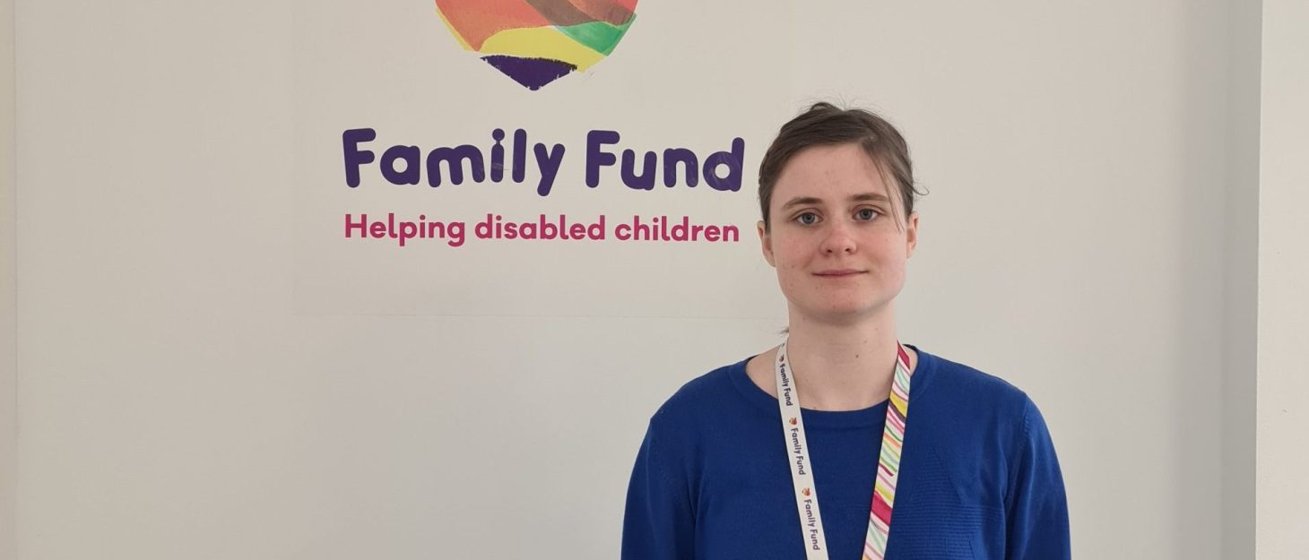

## Joining us as a trustee

Family Fund trustees fulfil their roles on a voluntary basis. Our trustees will usually be expected to serve for at least one term of three years but can serve for a second term and in exceptional circumstances a short extension beyond that may also be considered.

The Board of Trustees is the governing body of Family Fund and is responsible for ensuring the charity operates properly and effectively.

Trustees provide Family Fund with vital skills, expertise, experience and commitment essential to the governance of the charity. Any one trustee is not expected to have everything we need; we seek a board that as a whole can lead our Group.

Trustees have key responsibilities for an organisation.  They are in law the guardians of its purpose and are expected to direct the strategy, working with the executive team to do so. They have financial oversight, are responsible for resources and are expected to ensure the organisation stays within the law. We are seeking to appoint a new trustee to the Board and to the Finance, Audit and Risk Committee who is a qualified accountant.

We seek to have a broad and diverse range of experience and skills within our trustee group, and as a charity supporting the needs of families raising a disabled or seriously ill child we encourage applications from those who have a passion and commitment to improve the lives of such families. To be a trustee at Family Fund requires time, understanding and effort.

## A diverse Board

We welcome candidates of any background who have the required skills and experience to be a trustee. We would like to particularly encourage those with disabilities or long-term conditions or who are parents or carers of children and young adults with disabilities or serious illnesses to apply, to bring perspectives of lived experience.

We monitor the diversity of our Board annually and in September 2023, 12 out of 13 Trustees responded to our Inclusion data survey. Of that group, four declared a disability, our gender balance was 50% female and 50% male and three responded as black/ black British, Asian/ Asian British or African Caribbean. Five Trustees have experience raising or caring for a child with a serious illness or disability, and three of our Trustees are based in the devolved nations, ensuring that families right across the UK are represented at our Board table.

## Meet some of our trustees

**You can read the profiles of all our trustees at** www.familyfund.org.uk/about/governance/trustees/

### Gareth Lambert, trustee since 2017

**Gareth Lambert, trustee, and Chair of the Finance Audit and Risk Committee (FARC), shares his reflections on the importance of the Committee and the value that a qualified accountant will bring to the Board and Committee.**

**Gareth joined the Board in December 2017 and is in his final term as a trustee.**

**What do you find rewarding about your role as a trustee and Chair of FARC?**

As Committee Chair I find the role hugely valuable and personally fulfilling.  It provides a real insight into the inner workings of the Group, whilst simultaneously bringing to life many of the strategic challenges and risks faced by the Board and Management team.  The Committee members bring together a wealth of experience and perspective, that makes it a genuine pleasure for me to act as Chair.

**Tell us about the FARC Committee and why it is vital for strong governance?**

Our Finance, Audit and Risk Committee is a significant subcommittee of the Board of Trustees, providing oversight of the Group’s financial reporting process, the audit process – both internal and external, the system of internal controls including business continuity and information governance, the identification and management of significant risks and its compliance with laws and regulations.    
  
We are fully committed to effective governance, and this Committee ensures oversight of these key group functions in a completely transparent and supportive manner.  The Committee reviews its own performance bi-annually, to ensure it is operating at maximum effectiveness and recommends any changes it considers necessary to the Board for approval. With such a wide-ranging remit, the Committee operates across all aspects of the Group, providing challenge, insight and guidance to management on all significant strategic, financial and operational matters.

**What are you hoping for from this appointment?**

Our aim is to strengthen the already established Committee with further knowledge and experience, to ensure that the Committee can maintain its obligations around objectivity and provide suitable challenge and support to the Group*.*

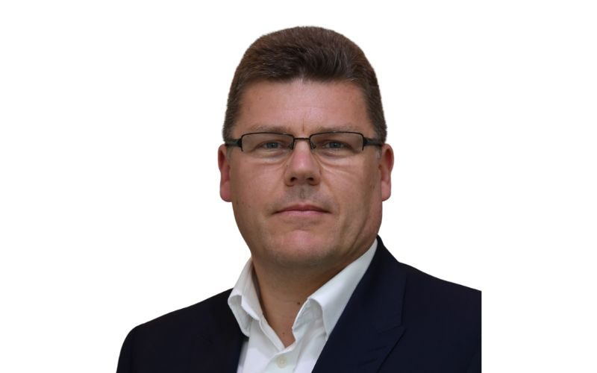

**Meet some of our trustees**

**Two of our Trustees share their reasons for joining and their experiences of being a Family Fund trustee.**

### Emma Pinnock, trustee since 2021

**What prompted you to become a trustee of Family Fund?**

Having previously heard about Family Fund and seeing the impact of their work first hand, it was an honour to be considered as a Trustee for the Charity.  The work Family Fund does, and its impact is far reaching and really reflects my own values, work and life experiences, so exploring the opportunity to be a trustee was a very easy yes.

**What do you bring to the Board, professionally or personally?**

Personally, I have a son with Down syndrome and professionally, I have worked in the Special needs sector for over 20 years as a teacher and now consultant.  Both experiences add to my understanding of some of the realities for the families who are supported by Family Fund and helps me to support the Charity to remain focused on the realities as well as the practicalities of running a charity.

**What do you find rewarding about being a trustee?**

Sharing with and helping to support such an important Charity is extremely rewarding. Being aware of the difficulties families can face when they have a child with additional needs, leads to a sense of hope and pride when a family story is shared,  a McCain advert shares family Fund or I am able to share the work of the Family Fund with an organisation or family who is in need.

**Can you tell us more about your role as the Chair of Safeguarding Committee and the importance of that Committee for good governance?**

As Family Fund focuses on families who can be understood as vulnerable, safeguarding is a pivotal element of the work they do.  The fact that there is a dedicated committee ensures that Safeguarding remains a focus and topic of review throughout the important work carried out by the Family Fund group.  Becoming the chair of the safeguarding committee is an extension to my overall role of being a trustee.    There is such a team effort on the board that my expertise and focus in this area are fully complimented and supported by my peers which only strengthens the committee, the board and ultimately the charity.

**What would you say to someone thinking about becoming a trustee for the first time?**

If you have the skills, passion and desire to positively impact the lives of others, then just do it. It is so rewarding.  You will learn a lot and you are not alone.  Being a trustee at Family Fund is so well supported, the induction is very useful, and everyone is willing to help.

**Meet some of our trustees**

### Shona Elliott, trustee since 2021

**What prompted you to become a trustee of Family Fund?**

As a mum to a child with complex needs, I was looking for a way to contribute more widely to the community of families I had come to love and be a part of. Knowing the unique challenges faced by families of children with different needs but also the desire to want your child to reach their potential, I felt I could make a worthwhile contribution and was excited about the opportunity to do so with Family Fund.

**What do you bring to the Board, professionally or personally?**

Professionally I bring skills in communication, policy and political influencing. Although Family Fund does not directly campaign, messaging is important as the charity seeks to raise awareness of issues facing families with seriously ill or disabled children. In terms of the personal, I hope I am able to help ensure trustee discussions remain centred on the families the charity exists to support.

**What do you find rewarding about being a trustee?**

The opportunity to work with such a talented group of trustees and staff, who are all committed and passionate about the aims of the charity. It is also important for me to put my skills towards and use my voice for the very goal I am passionate about: ensuring children regardless of their level of need and family income, have the opportunity to explore all life has to offer and aspire to great things.

**Can you tell us more about your role on the Board of FFBS?**

My role on the Board of Family Fund Business Services has helped me push myself to learn new skills and operate in an environment that is not familiar to me. Therefore, it has been an excellent opportunity for my own personal growth which I am very grateful for. The FFBS team are an exceptional and talented group of people who I feel privileged to support and it continues to be an exciting space to participate in.

**What would you say to someone thinking about becoming a trustee for the first time?**

Go for it! If you have the passion, courage and drive to contribute and push yourself to learn, then get involved.

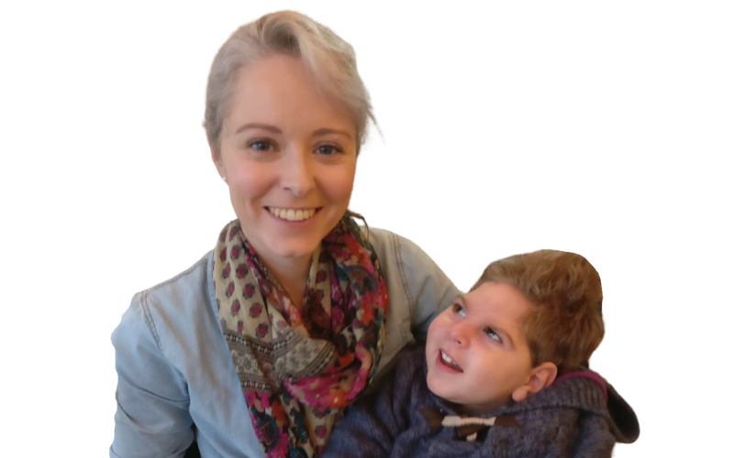

## Trustee role and responsibilities

Those who serve on Family Fund’s Board of Trustees have duties, responsibilities and liabilities both under company law as directors and under charity law as trustees.

### The core duties of a trustee are:

* To ensure that Family Fund complies with its governing document, charity law, company law and any other relevant legislation or regulations.
* To ensure that the organisation pursues its objects as defined in its governing document.
* To ensure that Family Fund applies its resources exclusively in pursuance of its objects. (It cannot spend money on activities which are not included in its own objects, no matter how worthwhile and charitable those activities are).

### In exercising these duties:

* To contribute actively to the Board of Trustees’ role in giving firm strategic direction to Family Fund, setting overall policy, defining goals, setting targets, and evaluating performance against agreed targets.
* To promote and safeguard the good name and values of Family Fund.
* To ensure the effective and efficient administration of Family Fund.
* To ensure the financial stability of Family Fund.
* To protect and manage the property of Family Fund, and to ensure the proper investment of its funds.
* To appoint the Chief Executive and Company Secretary of Family Fund and monitor their performance.
* In addition to the above statutory duties of all trustees, each should use any specific knowledge or experience they have to help the Board reach sound decisions. This will include scrutinising board or committee papers, leading discussions, focusing on key issues, and providing advice and guidance requested by the Board on new initiatives, or other issues relevant to the area of Family Fund’s work in which the trustee has special expertise.

### To observe the duties of company directors:

* Duty to act within powers; to promote the success of the company; to exercise independent judgment; to exercise reasonable care, skill and diligence; to avoid conflicts of interest; to not accept benefits from third parties; to declare interest in proposed transactions or arrangements.

### Each trustee must:

* Have a commitment to the aims and work of Family Fund.
* Have a willingness to devote the necessary time and effort, including attending all board and other necessary meetings.
* Have strategic vision and be able to understand and assess risks.
* Have good, independent judgement.
* Have an ability to think creatively.
* Be willing to speak their mind.
* Understand and accept the legal duties, responsibilities and liabilities of trusteeship.
* Be able to work effectively as a member of a team and to maintain good working relations.

The role description and person specification for the Trustee role can be found at the end of this pack.

### The practicalities

A Family Fund trustee carries out their role and responsibilities by working closely with other members of the Board, and with the staff of the charity. This will usually involve:

* Regular attendance and contribution to board meetings which are normally held four times a year during March, June (AGM), September and December; plus attendance at a strategy/development day once a year. Many of our meetings with trustees are held virtually. Attendance in person is likely to be required twice a year, with at least one of these meetings being in York. Reasonable travel and accommodation expenses will be reimbursed.
* All trustees are appointed to one of the standing committees: FFBS Board, overseeing the trading subsidiary; Finance, Audit and Risk - dealing with financial controls; People and Nominations - dealing with staff conditions of service and recruitment of trustees; and the Safeguarding Committee. Membership is determined based on skills, experience, interest and needs of the Charity. Other committees are formed as required.
* Occasionally representing Family Fund at external events.
* Using their particular skills and expertise to assist where appropriate with the work of Family Fund.
* The overall anticipated time commitment is around one day a month, or 12 days in total a year.

## The liabilities of trusteeship

Trustees are ultimately responsible for everything the charity does and how it does it. They must ensure all activities and actions are within and accountable to the law.

In doing this they have a duty to act in good faith. Trustees must avoid conflicts with any personal interests and should declare those that do arise. They may not profit from trusteeship, although appropriate expenses are reimbursed.

Instances of trustees being found liable for the misconduct of charities are rare in the UK. However, it is important trustees understand what their potential liabilities are. Trustees can be held personally liable for:

* Breach of trust – for example spending money inappropriately, or engaging in non-permitted political activity.
* Breach of fiduciary and statutory duties – for example using assets to procure benefit for the trustees.
* Fraudulent trading – incurring a debt knowing it cannot be repaid.
* Acting as a company director when disqualified.
* Failure to comply with statutory requirements, e.g. health and safety, HMRC, financial services.

The establishment of Family Fund as a company limited by guarantee protects trustees’ liability to £10 each, provided they have acted in good faith.

More information about being a trustee of a charity can be found in the Charity Commission for England and Wales’ publication *The Essential Trustee: what you need to know, what you need to do* at: <http://www.comisiwnelusennau.gov.uk/publications/CC3.aspx>



## Trustees’ standards

The following standards and commitments are expected of trustees.

### General

Trustees must act with probity, due prudence, and should take and consider professional advice on anything in which the trustees do not have expertise themselves.

* Except where legally authorised, trustees must not gain financial or other material benefit for themselves, their families, or their friends from Family Fund.
* A trustee must not place him/herself under any financial or other obligation to outside individual organisations that might influence him/her in the performance of his/her official duties.
* Trustees should conduct themselves in a manner which does not damage or undermine the reputation of Family Fund, or its staff individually, or collectively, and should not take part in any activity which is in conflict with the objects, or which might damage the reputation of Family Fund.
* Trustees must take joint responsibility for decisions taken including those determined by a nominated sub-committee.
* Trustees who are part of a nominated sub-committee must take all reasonable steps to ensure that other trustees are kept fully up to date with information upon which decisions may be taken.

### Responsibilities

* Trustees must, with the help of the Group Chief Executive, formulate and
* review regularly Family Fund’s vision, strategic objectives and plans.
* Trustees must ensure, with professional advice where appropriate, that the Family Fund complies with all regulatory and statutory requirements and must exercise overall control over Family Fund’s financial affairs.
* Trustees must be familiar with, and regularly review the constitution of Family Fund.
* Trustees must annually review Family Fund’s performance against its vision and objectives.
* Trustees must attend all meetings regularly. If attendance is proving problematic, a trustee can request a leave of absence or sabbatical.
* Trustees should bring a fair and open-minded view to all discussions, and should ensure that all decisions made are in Family Fund’s best interests.
* Trustees must aim to foresee, and avoid any conflict of interest. Where one arises, the trustee must declare it, and absent him/herself from the meeting.
* Confidential information or material (relating to families, staff, commercial business etc.) provided to or discussed at a trustee meeting, must remain confidential, within the confines of the meeting, and be managed according to relevant legislation.
* Trustees should be as open as possible about the decisions they take, giving reasons where appropriate and restricting information only when wider interest requires it.

Trustees have a responsibility to develop and ensure the maintenance of a properly constituted, balanced and competent board, including clear procedures for selection, training, retirement and, if necessary, removal of trustees and to ensure arrangements are followed for recruiting the Chair and members of sub-committees.

### Board responsibilities to staff

* Trustees must ensure there is a clear understanding of the scope of authority delegated to the Group Chief Executive.
* Policies and strategies agreed by the Board should be clear and explicit, and come from the Board as a whole.
* Trustees should act fairly and in accordance with best practice principles in making decisions affecting the appointment, recruitment, professional development, appraisal, remuneration and discipline of the Chief Executive and other staff.
* Trustees must understand and accept the difference in roles between the Board’s governance role and the Chief Executive’s operational management responsibility.
* Trustees should ensure that they do not act to undermine the Chief Executive by word or action. If a trustee has concerns about the performance of a member of Family Fund staff, including the Chief Executive, this should be taken up with the Chair.
* If a trustee has a concern about financial irregularities within Family Fund, these should be addressed to the Chair who will act upon the information appropriately and in accordance with agreed procedures.

### The Group Chief Executive will:

* Provide the trustees with timely and relevant information in order to allow the Board to carry out its governance function.
* Provide the Board with advice when necessary, ensuring that external professional advisors are available as and when needed.
* Work in partnership with the Board to ensure that Family Fund fulfils all its statutory and legal responsibilities.
* Invest time, money and other resources in order to help support and further develop good governance.
* Provide the Board with the necessary administrative and other support that they need to govern well.
* Reimburse trustees’ travel and subsistence expenses incurred in the course of their duties as trustees.



## Trustee role description

Trustees have ultimate responsibility for directing the affairs of Family Fund, ensuring that it is solvent, well-run and delivering the charitable outcomes to the benefit of the public for which it has been set up.

The role of a trustee is to govern the charity. This is achieved by making decisions collectively as a board. A trustee has no power to act on their own unless powers are delegated to them. Although trustees act collectively as a board, for the most part the duties owed by trustees to the charity are personal to the individual trustee, so the individual trustees are each responsible for the actions of the board as a whole.

As well as being a trustee of a charity, a Family Fund trustee is also a company director with all the legal duties that this entails.

### Main responsibilities of a trustee

* Ensuring that the charity complies with charity law and with the requirements of the Charity Commission as regulator; in particular ensuring that the charity reports on what it has achieved by submitting Annual Returns and accounts as required by law.
* Ensuring that Family Fund does not breach any of the requirements or rules set out in its governing document and that it remains true to the charitable purpose and objects set out there, reviewing the governing document regularly (at least every three years) to ensure it is fit for purpose.
* Complying with the requirements of other legislation and other regulations which govern the activities of Family Fund.
* Ensuring that Family Fund financial obligations are met and that there are adequate financial controls in place to ensure all money due is received and properly applied, and that all assets and liabilities are recorded.
* Ensuring that intangible assets such as organisational knowledge and expertise, intellectual property, brand, good name and reputation are recognised, used and safeguarded.
* Ensuring that Family Fund has a clear vision, mission and strategic direction and is focused on achieving these.
* Ensuring that operational plans and budgets and the fundraising strategy support the vision, mission and strategy.
* Ensuring that Family Fund is, and will remain, solvent.
* Considering external professional advice on all matters where there may be material risk to Family Fund, or where the trustees may be in breach of their duties.
* Acting with integrity and avoiding any personal conflicts of interest or misuse of Family Fund funds or assets.
* Using reasonable care and skill in their work as trustees, using their personal skills and experience as needed to ensure that Family Fund is well-run and efficient.
* Avoiding undertaking activities that might place Family Fund assets, funds or reputation at undue risk.
* Acting reasonably and prudently in all matters relating to Family Fund and always in the charity’s interests.

### Qualities of a trustee

* Commitment to the organisation
* Integrity, strategic vision and good/independent judgement
* A willingness to devote the necessary time and effort to their duties as a trustee
* Ability to take decisions for the good of the organisation
* Good, independent judgement
* Good communication skills
* Tact and diplomacy
* Willingness to speak one’s mind and listen to the views of others
* An ability to work effectively as a member of a team
* Understanding of the legal responsibilities and liabilities of a trustee.

### Desirable experience

* Commitment to the organisation
* Integrity, strategic vision and good/independent judgement
* A willingness to devote the necessary time and effort to their duties as a trustee

### General responsibilities of a trustee

In addition to the responsibilities already outlined, the trustee has the following general responsibilities:

* Ensuring the organisation applies its resources exclusively in pursuing its objectives.
* Contributing actively in giving firm strategic direction to the organisation, setting overall policy, defining goals, setting targets and evaluating performance against agreed targets.
* Safeguarding the good name and values of the organisation.
* Declaring any conflict of interest while carrying out the duties of a trustee.
* Being collectively responsible for the actions of the organisation and other trustees.
* Ensuring the effective and efficient administration of the organisation.
* Ensuring the financial stability of the organisation and the proper investment of the organisation's funds.
* Protecting and managing the property of the organisation.
* Attending meetings and reading papers in advance of meetings.
* Attending sub-committee meetings as appropriate.
* Participating in other tasks as they arise from time to time, such as interviewing new staff or helping with fundraising.
* Keeping informed about the activities of the organisation and wider issues which affect its work.

In addition to the duties of all trustees, each trustee should use any specific skills, knowledge or experience they have to help the Board of Trustees reach sound decisions. This will involve scrutinising board papers, leading discussions, focusing on key issues, and providing advice and guidance as requested by the Board on new initiatives or other issues relevant to an area of the organisation's work.

## Support in the role

We will make every effort to help you fulfil your role to the best of your abilities, and to support your development. We give all new trustees an induction and we have a board development programme to support you in developing your skills. We also offer a buddy system to build relationships among trustees and help you benefit from each other’s perspectives and expertise.

## Application process

For a confidential discussion about the role, please contact Tracy Evans, Group Director of HR and Facilities (tracy.evans@familyfund.org.uk / 07503 82224) who will arrange an appointment with Cheryl Ward, CEO or Gareth Lambert, Chair of FARC.

Please apply via our website.

**The closing date for applications is Sunday 7 April 2024.**

**Interviews will be held virtually via Microsoft Teams on Thursday 2 and Friday 3 May 2024.**



